
AMERICAN INTERNATIONAL UNIVERSITY-BANGLADESH
Faculty of Science and Technology
Department of Computer Science
CSC 3215: Web Technologies

Semester: Summer 2025-26 | Group No: |  | Section:

Group Members:
SL. | Student ID | Name | Role | Signature
1 | 22-48617-3 | Ashanul Bari Chowdhury | Group Leader | Ashanul
2 | 22-4627-1 | Tarifush Shajid | Member | Tarifush
3 | 25-61087-1 | Md.Hasnat | Member | Hasnat
4 | 24-58528-2 | Md.Akib Hossain | Member | Akib
Project Title
Beauty Salon Management System
Short Description
The Grand Hotel Management System is a web-based application designed to make daily hotel operations easier, faster, and more organized. It allows customers to search for available rooms, book their stays, and send special requests directly online. At the same time, it helps hotel staff, such as receptionists and room service workers, manage their daily tasks efficiently without using paper. The system also gives administrators a complete and clear overview of all bookings, user accounts, reviews, and hotel services, replacing old manual methods with a reliable digital solution.

Introduction
In the past, many hotels managed their room bookings, customer details, and staff tasks using paper records, notebooks, or basic spreadsheets. This manual process is very time-consuming and often leads to mistakes, such as double-booking a room, losing customer requests, or making billing errors. To solve this problem, we developed the Grand Hotel Management System. This project provides a centralized platform where different users have their own specific roles and dashboards. Customers can easily book rooms and check their history, receptionists can handle special services and generate invoices, room service staff can log their food or laundry deliveries, and admins can monitor the entire system. By bringing all these features into one secure website, our goal is to reduce manual work, prevent human errors, and make the hotel management process smooth and user-friendly for everyone.

ER Diagram

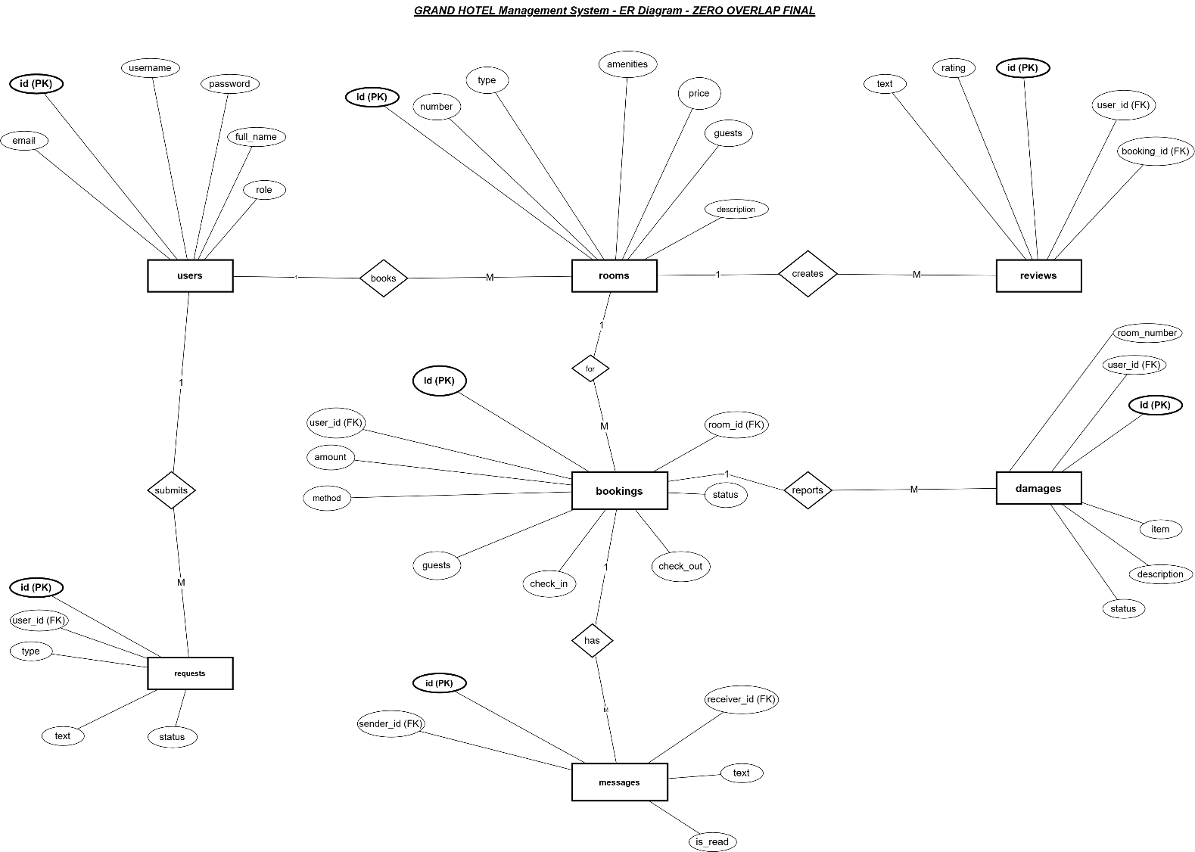

Use Case Diagram
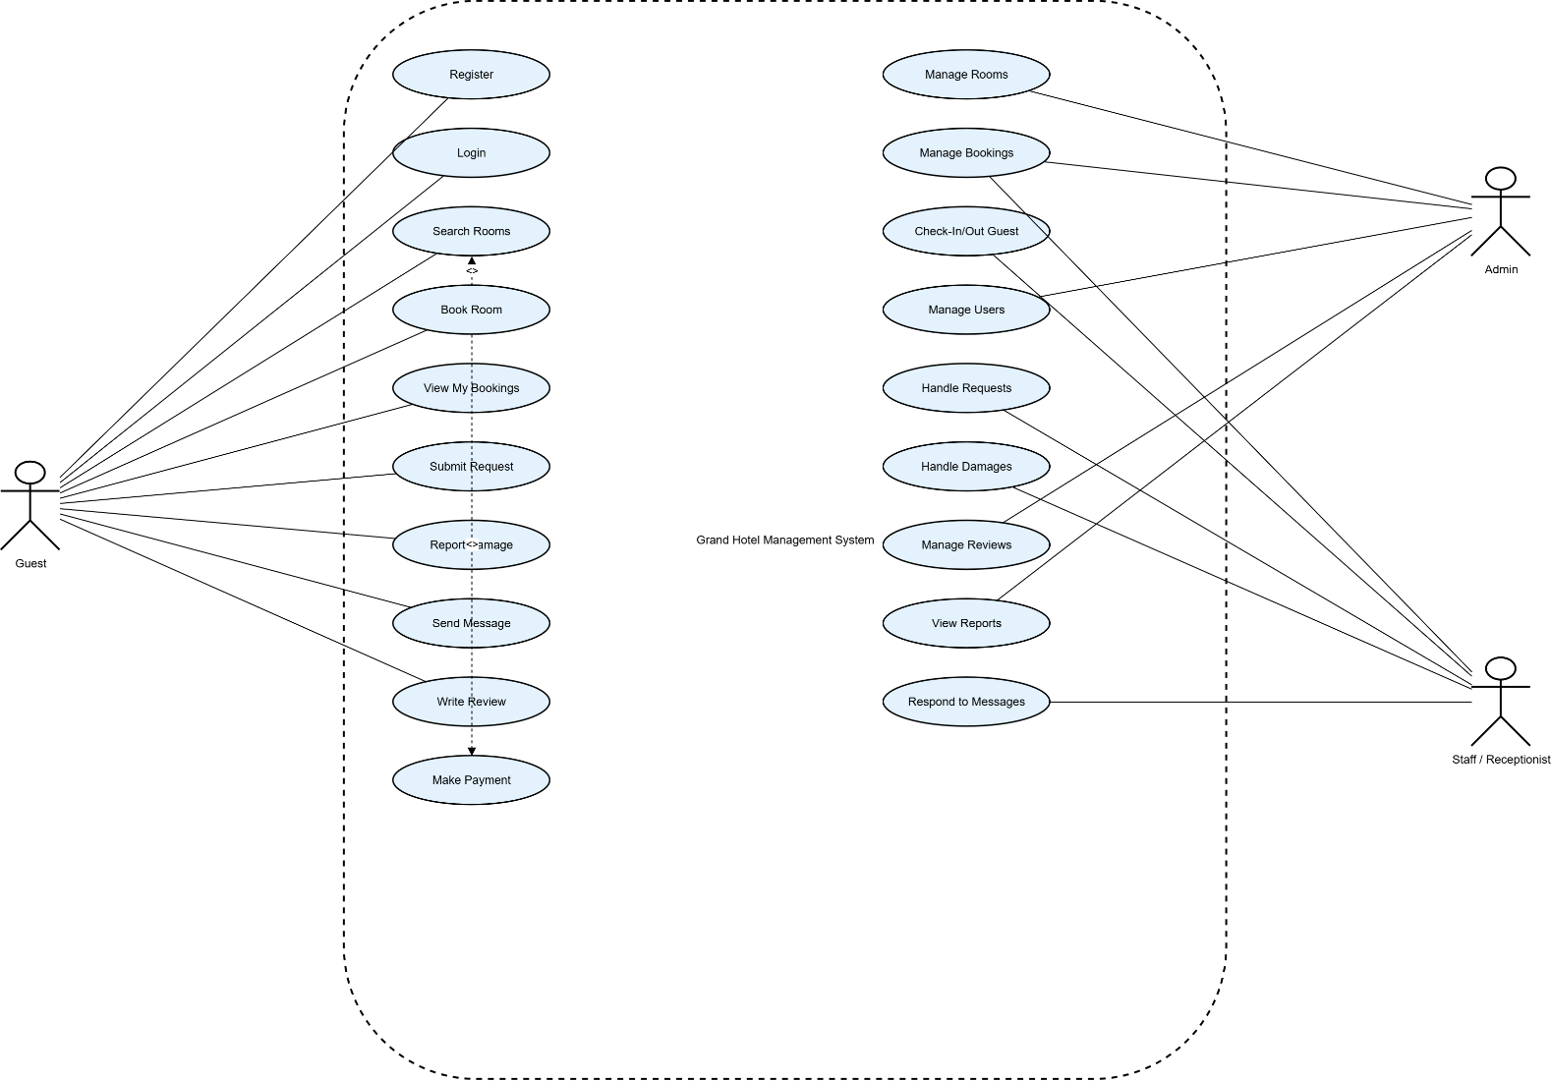
UI (Figma/Sketch)
Provide the tentative design of your system.

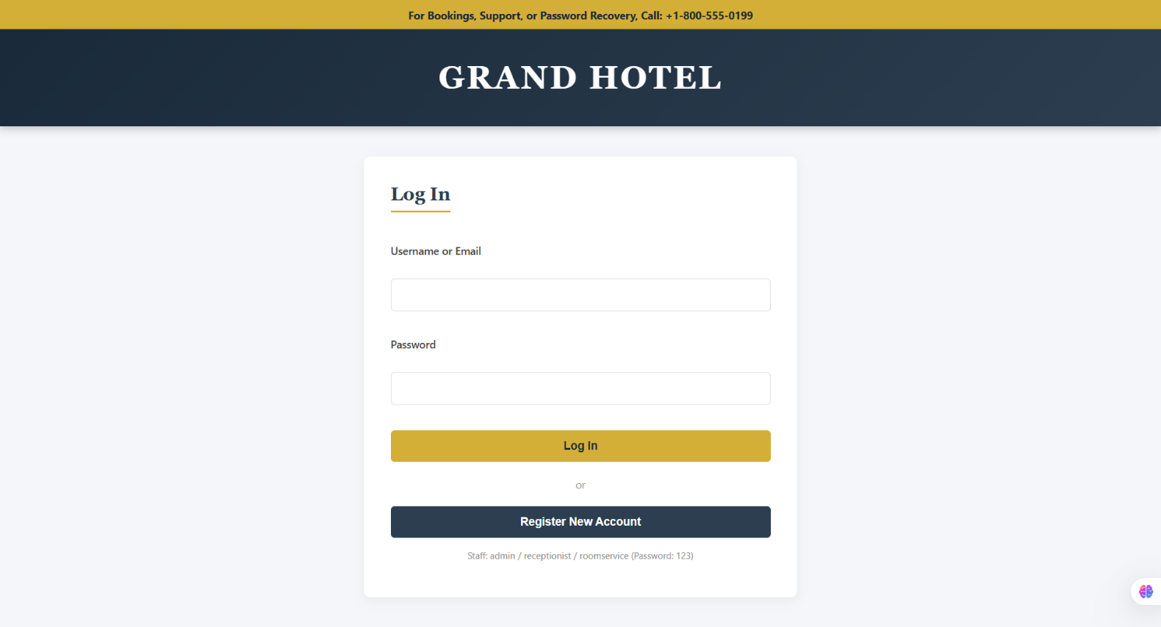

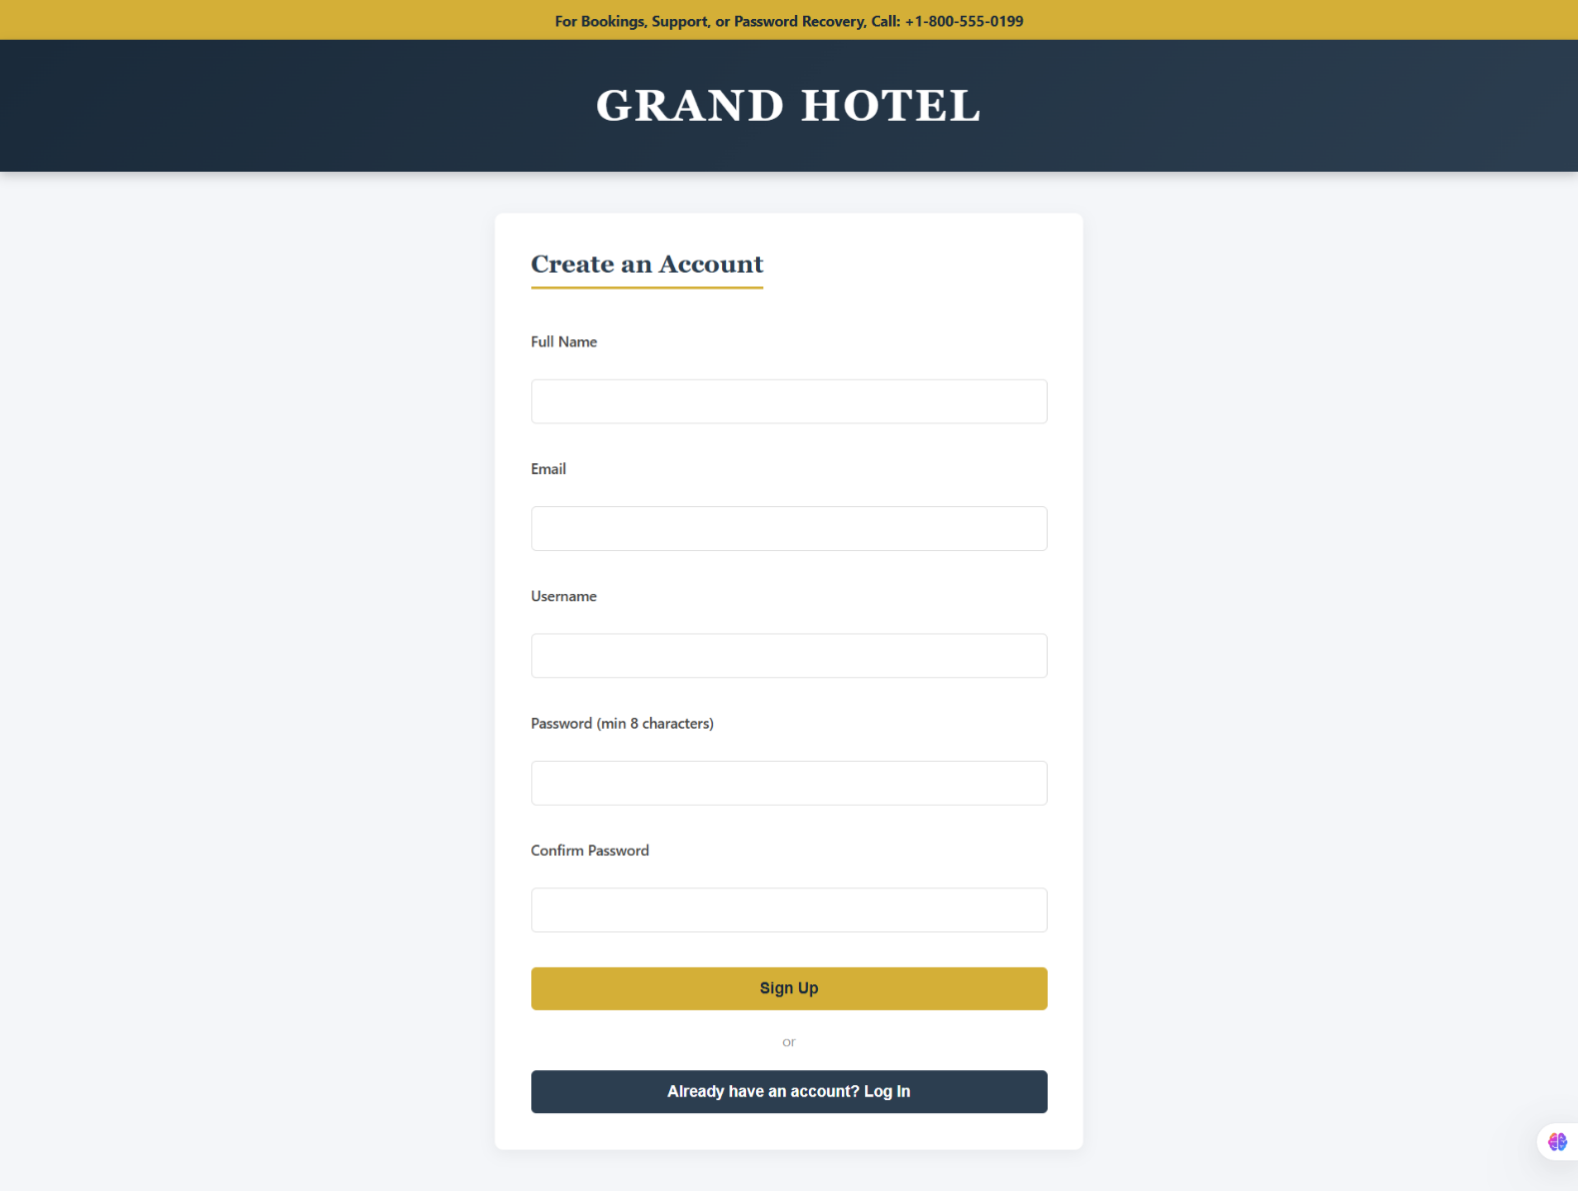
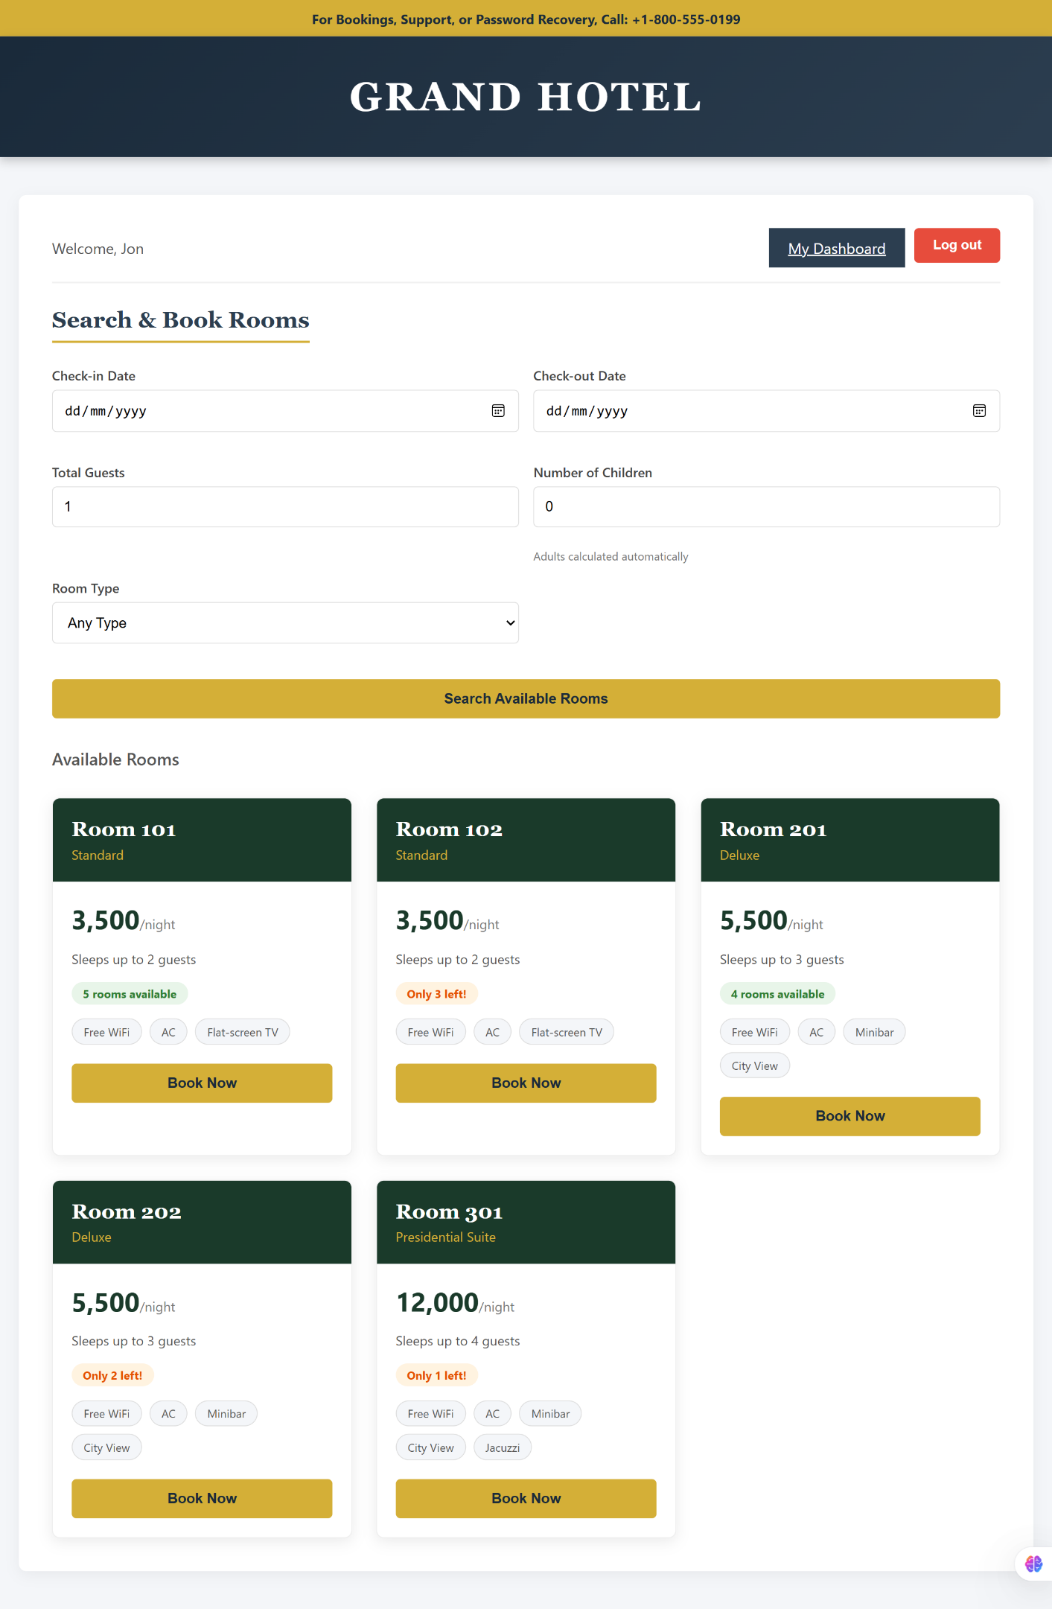
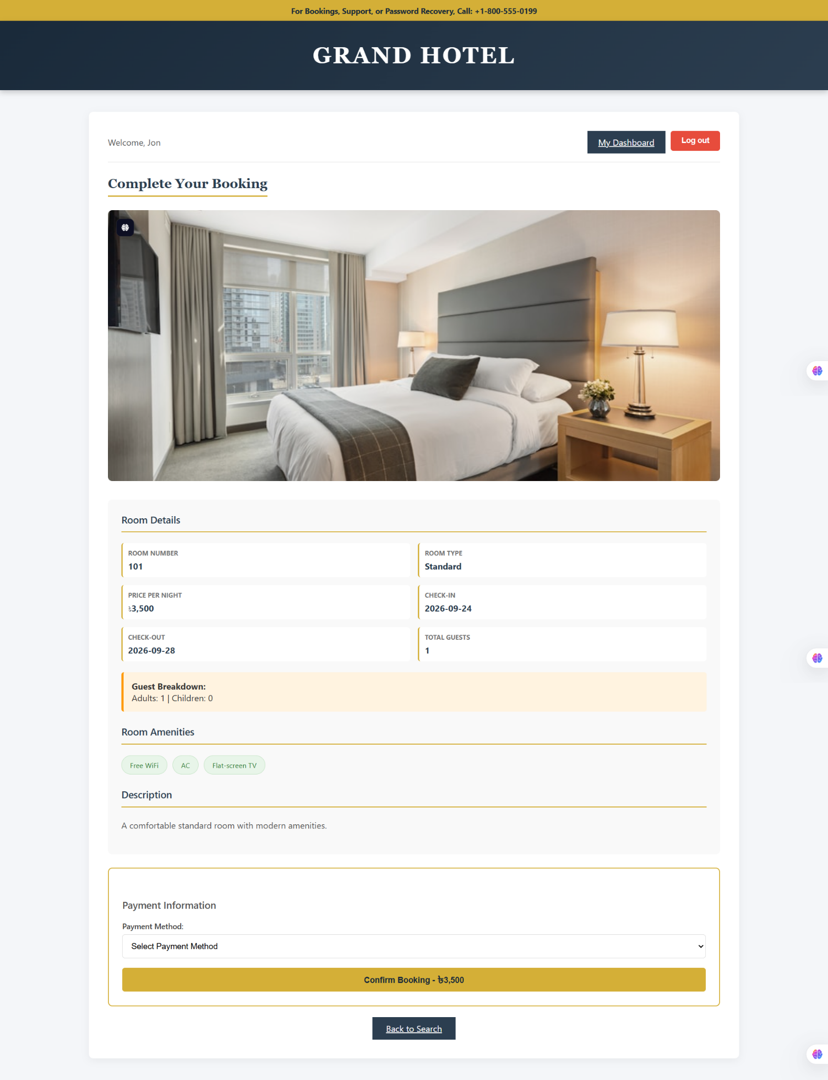

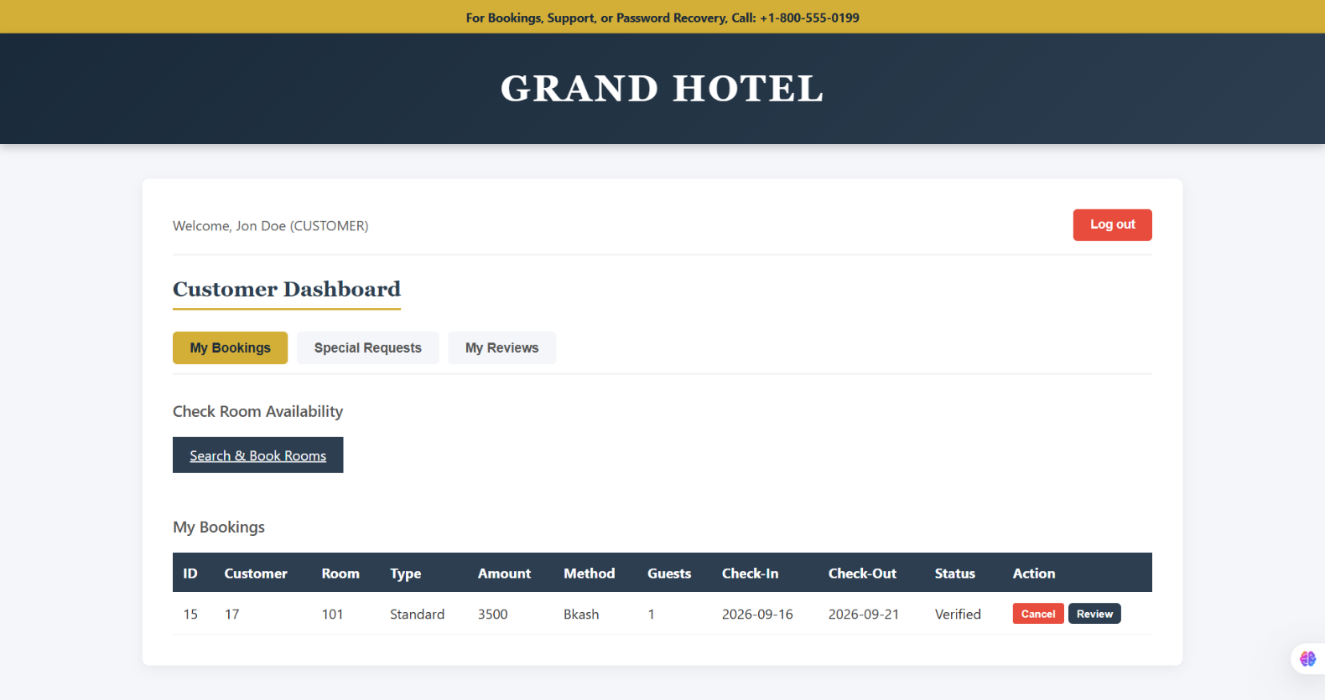

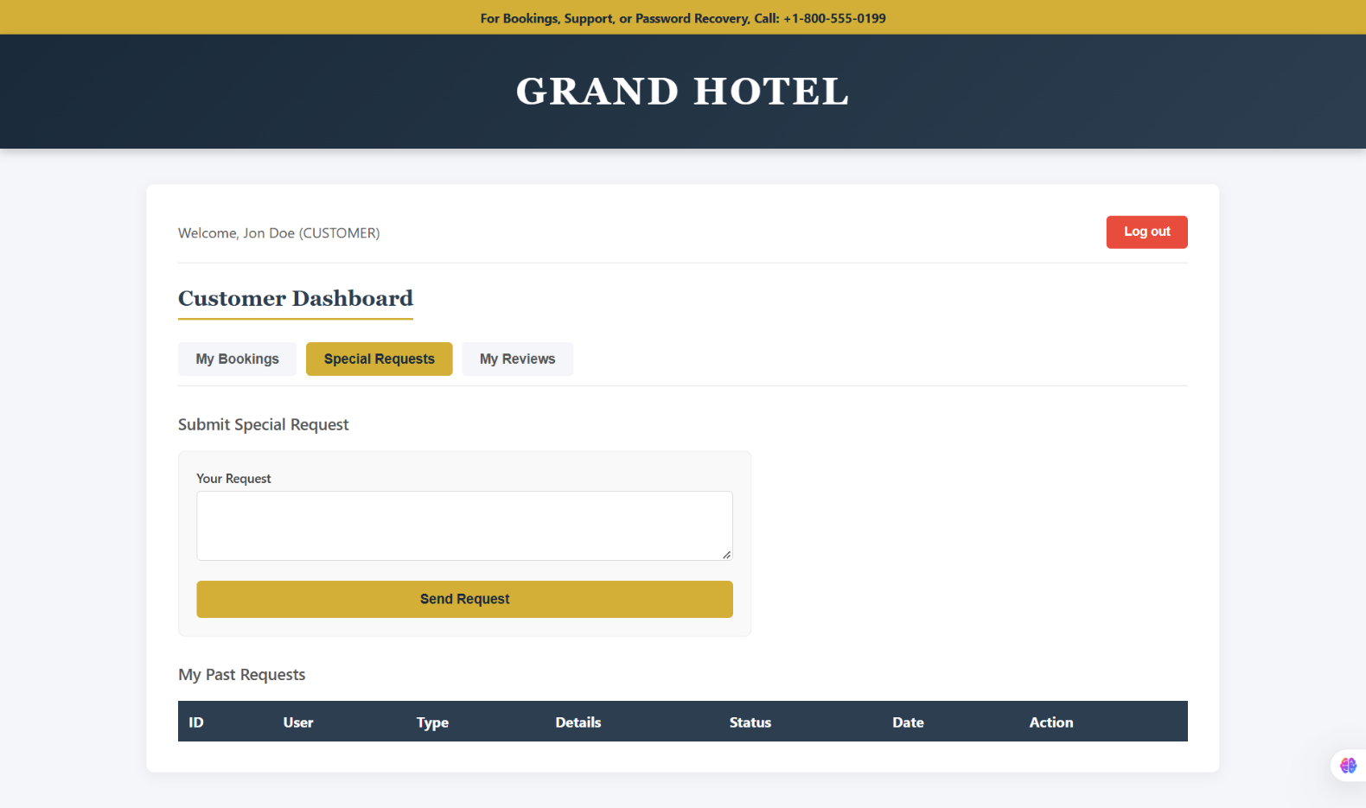

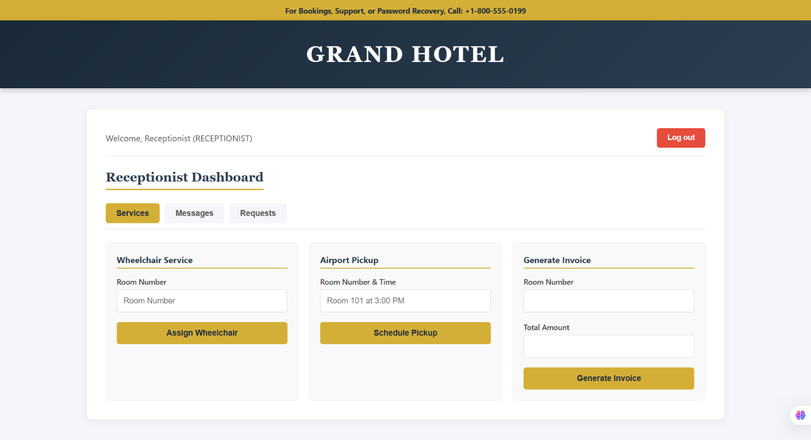

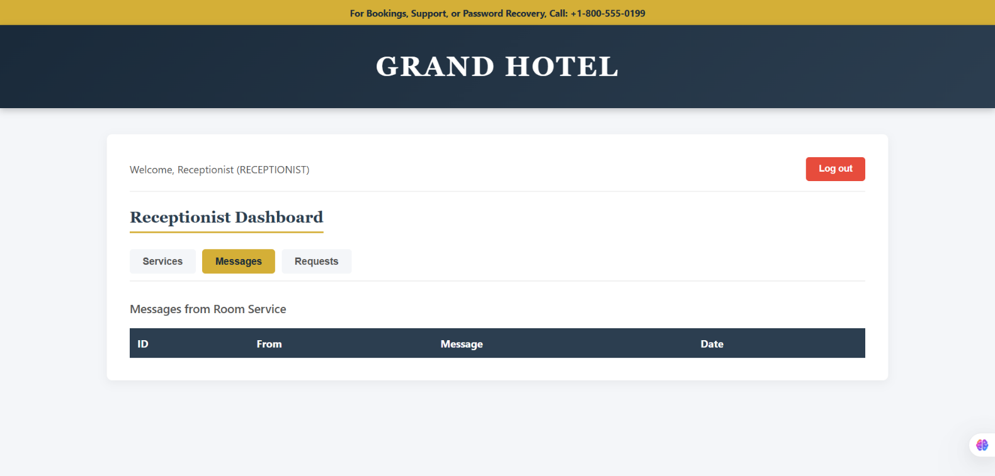

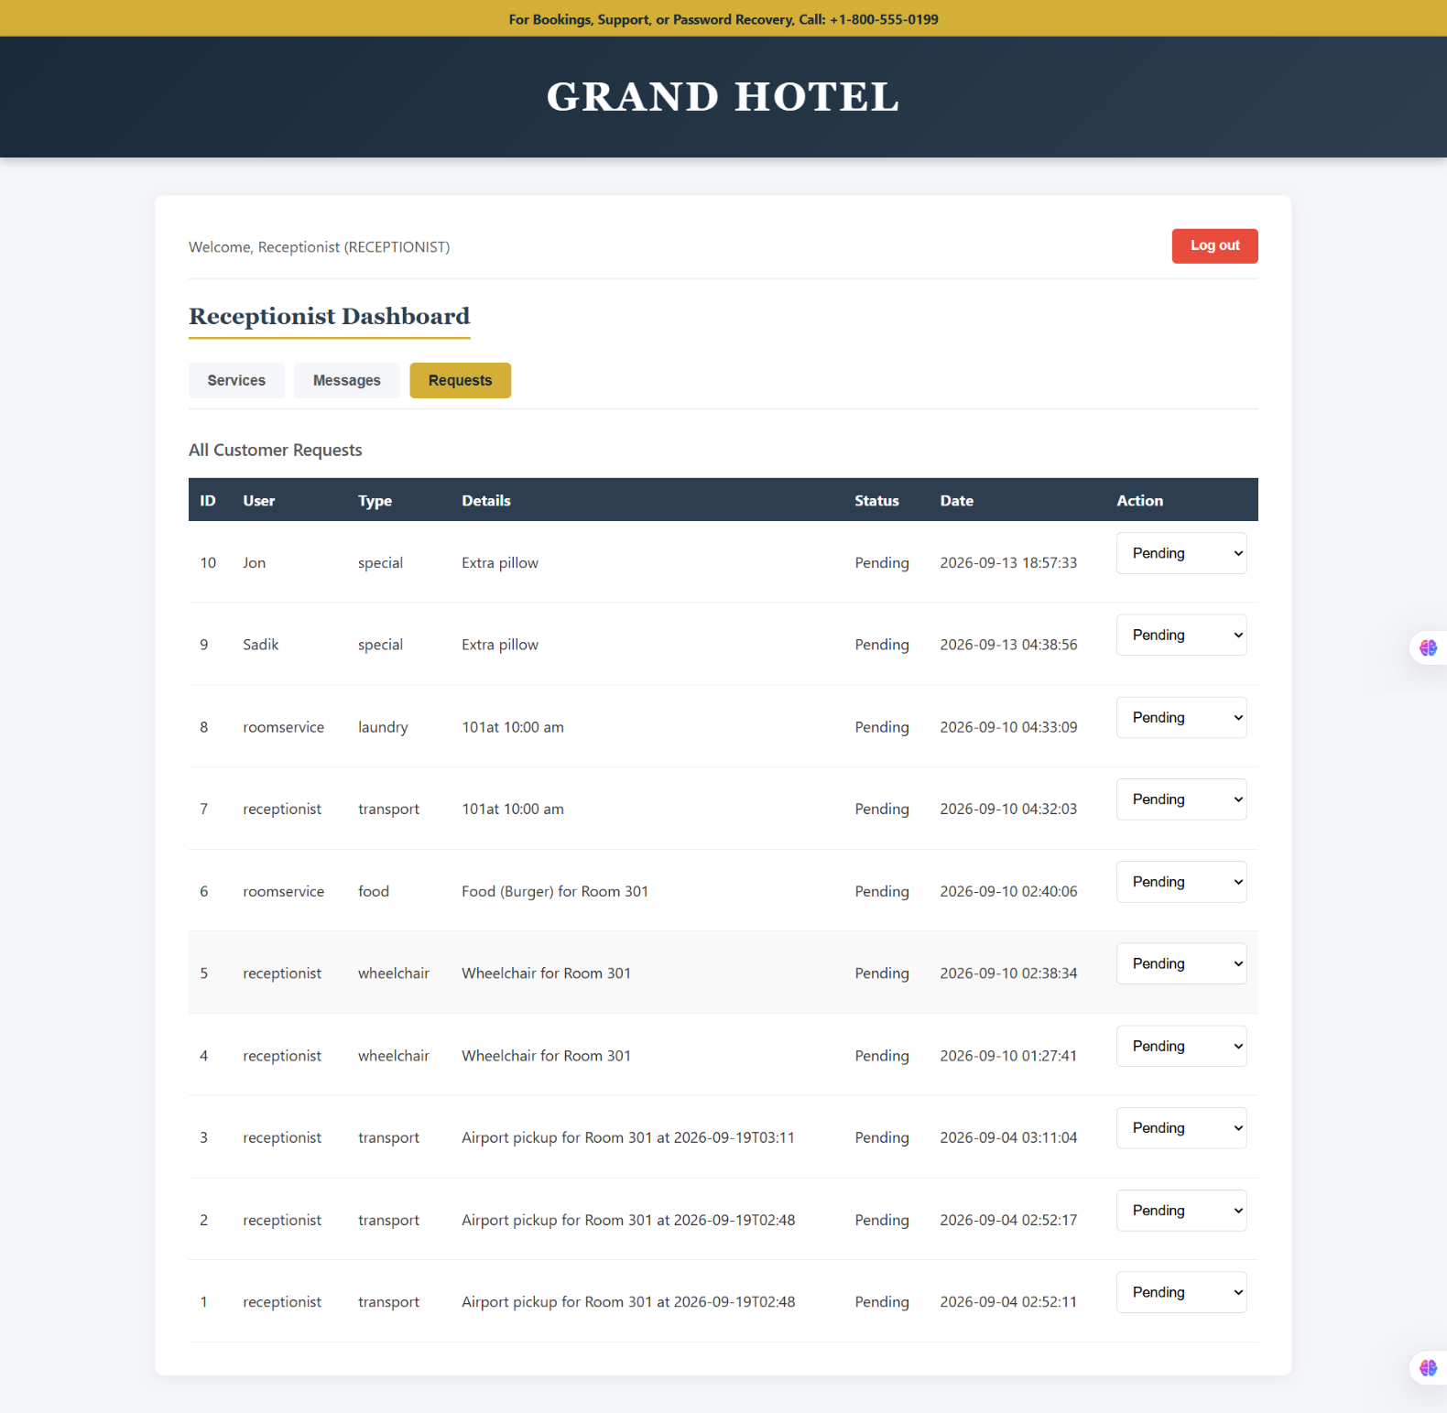

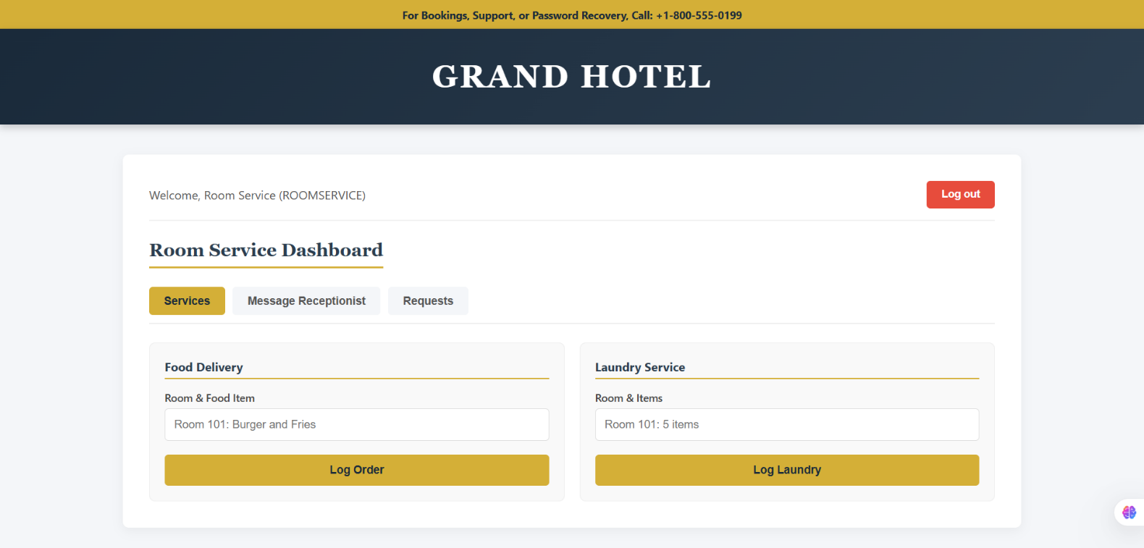

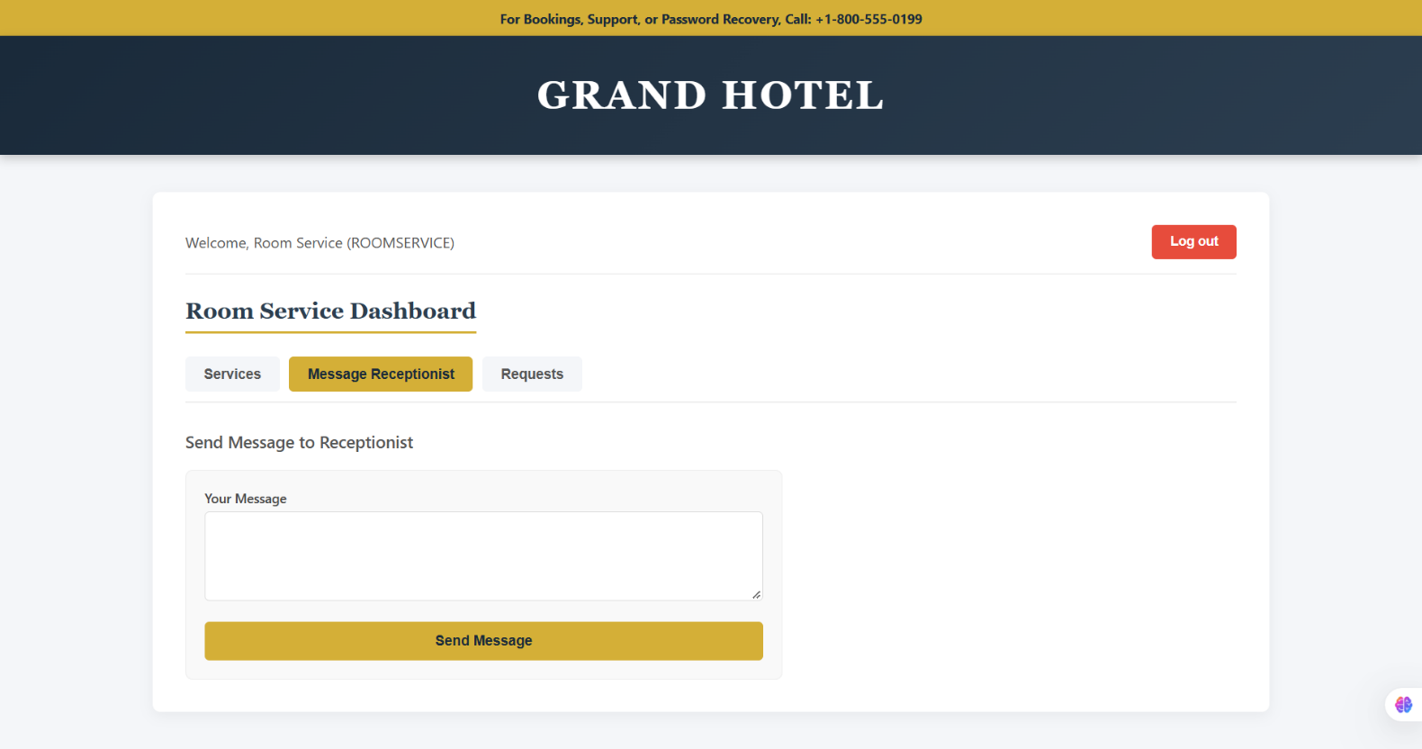

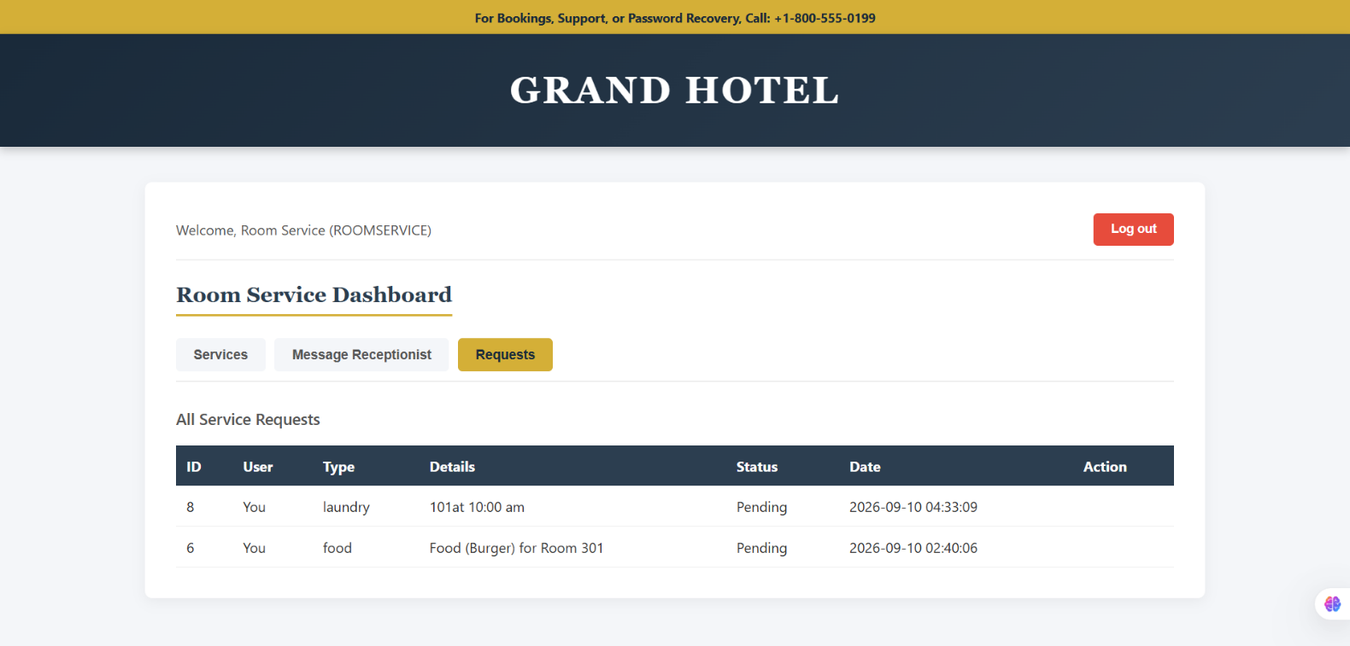

N.B: Each user type must have at least 3 distinct features different from the others. Additional features may be added if desired. Proposals with generic, incomplete, or duplicated features across user types will receive reduced marks under the criteria below.

